Layout for AC-powered Site
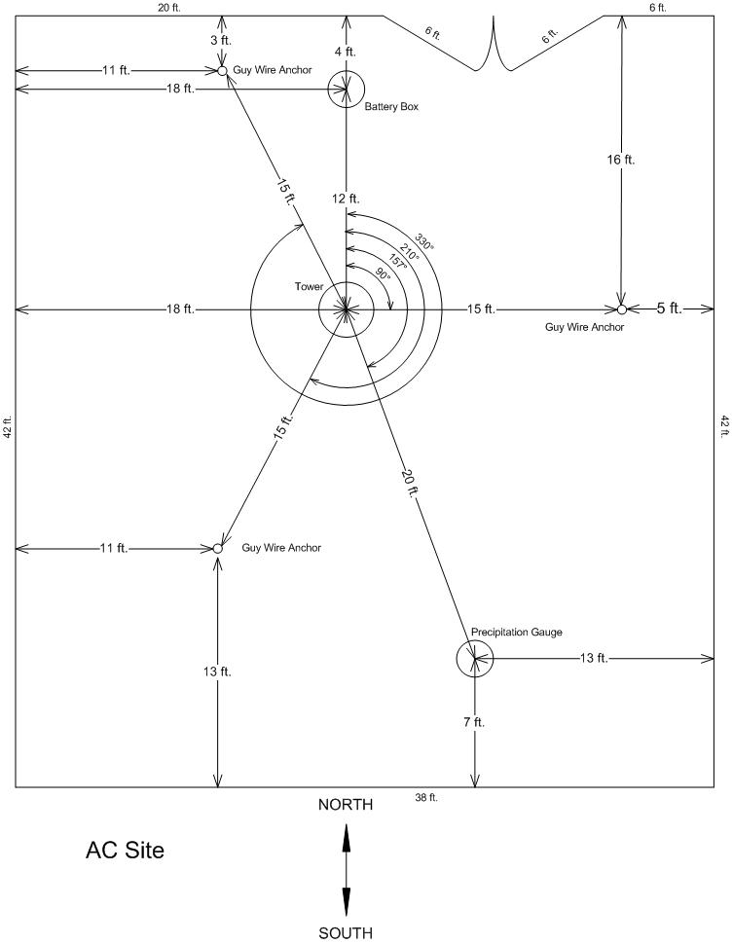

Copyright © 2007, Kentucky Climate Center, Western Kentucky University

