Layout for Solar-powered Site
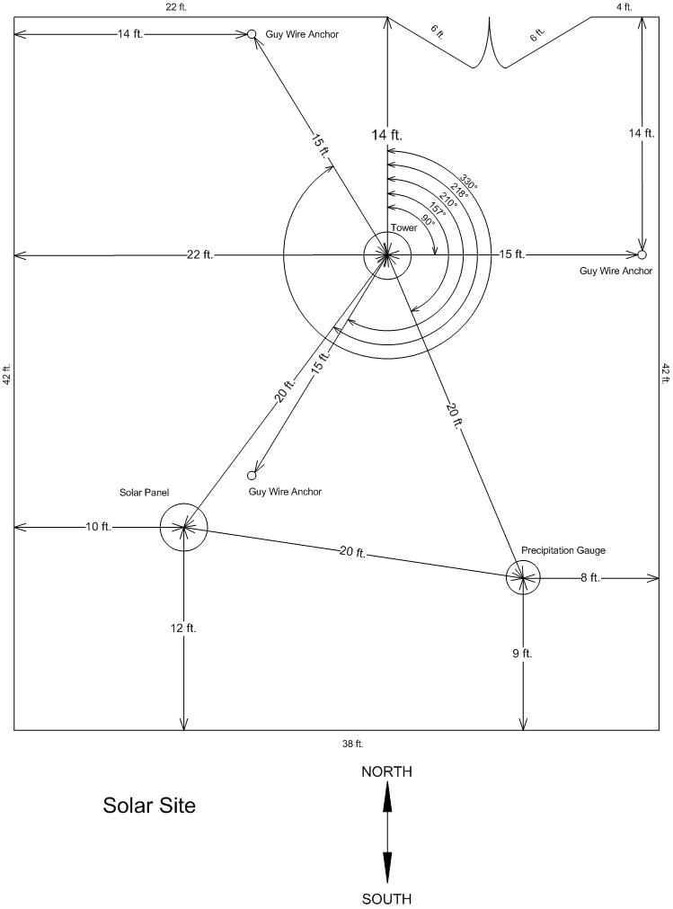
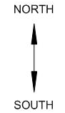

Copyright © 2007, Kentucky Climate Center, Western Kentucky University

