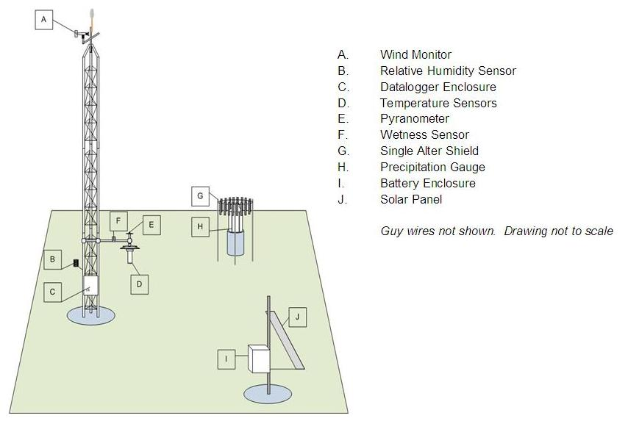

Sketch Diagram for Solar-powered Site
Copyright © 2007, Kentucky Climate Center, Western Kentucky University

